Results from the Workforce Diversity Survey
  - Office of Policy, Department of Employment and Economic Development (DEED)
  - April 2017

Executive Summary
The results presented here offer key insights about the current state of workforce diversity in Minnesota, including:
- To Minnesota’s employers, race is an important component of diversity—but not the only component of diversity.
  - The vast majority of businesses define diversity along three or more characteristics—most often race/ethnicity, gender, and age.
  - Almost half of employers whose employees all identify as non-Hispanic whites still perceive themselves as diverse.

- Most employers in Minnesota are actively trying to increase the racial diversity of their workforce, and the vast majority have already implemented at least one best practice in managing workers of diverse backgrounds.

- Small firms in Minnesota are less likely than large firms to report actively trying to increase diversity and to subscribe to common rationales for promoting diversity. Much of the attention around workforce diversity focuses on larger corporations, leaving the small business perspective out of the diversity conversation.

- Minnesota’s six regions provide employers with unique demographic backdrops that shape their perceptions of their own workforce diversity. Some strategies in managing diversity that make sense in the Twin Cities don’t translate to Greater Minnesota.

- Employers in the Education, Government, and Construction sectors are among the least racially diverse in Minnesota but are also the most likely to report actively trying to increase the racial diversity of their workforce. Education employers have the highest rate of any sector of engaging in best practices around managing diversity.
After a brief project background, this report will discuss how employers define diversity, whether employers perceive their workforces to be diverse, whether employers are seeking to increase diversity, and how employers are managing the diversity of their workforces.

Project Background
According to the latest available projections from the Minnesota State Demographic Center, Minnesota’s nonwhite or Hispanic population is expected to double between 2005 and 2035, reaching 25 percent of the total population. These population changes are not isolated to only certain areas of the state: each region is projected to become more racially and ethnically diverse over the coming decades than it is today.
Critically, the presence of racial employment disparities threatens to leave this growing part of the state behind. The percentage of working age adults in Minnesota who are unemployed or not in the labor force is 59% among Dakota, 48% among Ojibwe, 45% among U.S.-born African-American, 40% among Somali, and 38% among Hmong populations. That’s compared to just 22% among the non-Hispanic white population.
In spring 2016, DEED conducted a first-of-its-kind survey of Minnesota employers to understand their current approach to workforce diversity. Questions ranged from how employers define diversity, to their perceptions of how diverse their current workforce is, to what best practices they have used to manage workers of diverse backgrounds. The survey included nearly 3,000 Minnesota employers—both large and small businesses—in every region and industry. Over 1,000 responded, providing an unprecedented look at the business practices affecting Minnesota’s rapidly diversifying workforce.
This work is critical to helping us understand the employment outcomes of Minnesotans served in public workforce training programs. On a daily basis, state and local partners seek to connect an increasingly diverse group of job seekers to sustainable career pathways. In 2016, the state invested $8 million in workforce programming for underserved communities of color. These programs need to know whether Minnesota employers are ready to receive their talent. And this public workforce system needs to be ready to give small- and mid-size employers the resources they need to effectively employ staff from diverse backgrounds.
These results have a margin of error of 5 percent with a 95 percent confidence level. Full details of the methodology is available on DEED’s website.

How do employers define workforce diversity?
When Minnesota businesses talk about employee diversity for their organization, they most often refer to differences in the race, ethnicity, gender, age, national origin, and disability status of their workers (Figure 1).
88 percent of businesses define diversity along three or more characteristics provided in the survey. The most common definition, selected by eight percent of respondents, includes all of the above factors. This is followed by all of the factors except for criminal background (at five percent) and age and race/ethnicity (also at five percent). Four percent selected race/ethnicity alone.
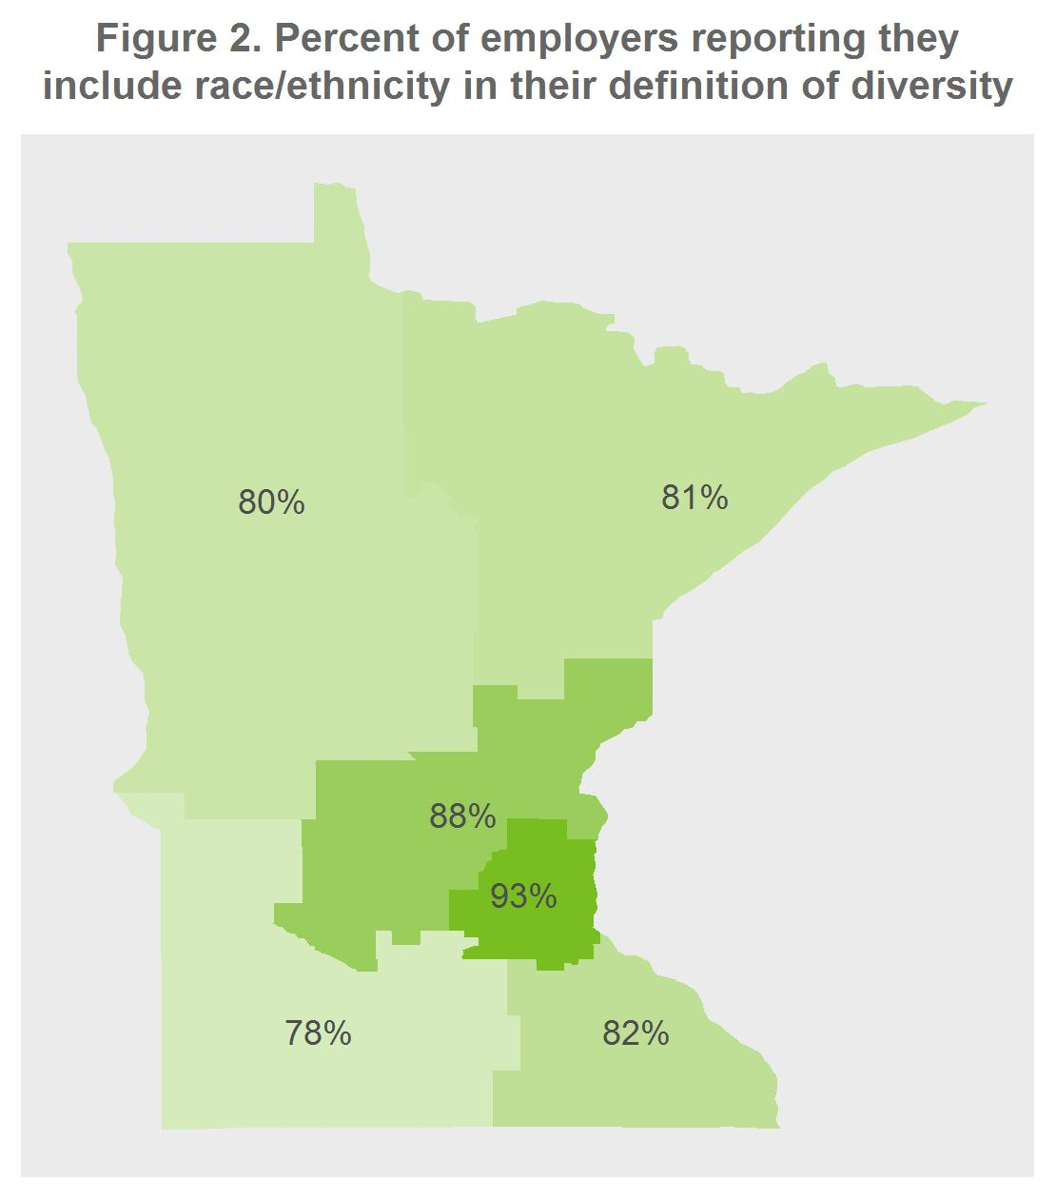
Employer definitions of diversity do vary significantly by region. Employers in the Twin Cities and Central Minnesota are more likely than employers in Southwest Minnesota to include race/ethnicity in their definition of diversity (Figure 2).
Employer definitions of diversity are also correlated with firm size: large employers tend to use a broader definition of diversity (Figure 3). (There are roughly equal numbers of firms in each size category; large firms employ over half of all workers in the state, and small- and medium-sized firms employ about equal portions of the remainder.)
Differences are most pronounced with national origin, disability, sexual orientation, religion, and veteran status, with large employers much more likely to include those in their definition than small employers. The order of most common factors also differs by firm size: among small employers, age is the second most common factor respondents include in their definition of diversity, above gender and national origin.

Employer definitions of diversity vary significantly by industry (Table 1).
Generally, across each industry, race/ethnicity, gender, and age are the top three factors included in the diversity definition by a significant margin. However, the industries that are the most traditionally male-dominated (Construction, Manufacturing, and Trade, Transportation, and Utilities) include Gender and Race/ethnicity at about the same rate, while industries that are traditionally more female-dominated (Education, Healthcare, and Leisure and Hospitality) see a significantly lower rate of including Gender. This could imply that employers’ definition of diversity is sensitive to traditionally under-represented groups in their industry that they are actively recruiting.
Similarly, employers in Construction, Manufacturing, and Other Services are most likely to include criminal background (over one in five), while those in Education and Financial Activities are least likely to (fewer than one in 10). Minnesota passed a so-called ‘ban the box’ law in 2014, which brought new awareness to the problem of employment discrimination faced by those with a criminal background. However, some occupations and industries, including Education and Financial Activities, are subject to state and federal regulations restricting the hiring of workers with a criminal background due to the sensitive nature of their work.
The factor with the highest variance by industry is sexual orientation, from a high of 63 percent of employers in Other Services to just 19 percent of employers in Natural Resources and Mining. Religion is another high-variance factor, with more than half of employers in Manufacturing, Healthcare, and Other Services including it in their definition compared to less than a third of employers in Leisure and Hospitality and Natural Resources and Mining.
Employers in Natural Resources and Mining, which includes farming operations, have relatively narrow definitions of diversity and a high rate of responding they don’t know or don’t have a definition of diversity. The context of racial diversity in agriculture is very unique, with many farms around the state hiring foreign workers on seasonal visas.

Table 1. Percent reporting they include the following in their definition of diversity, by industry
 | Con-struction | Edu-cation | Financial Activities | Govern-ment | Health-care | Leisure and Hospi-tality | Manu-facturing | Natural Resources and Mining | Other Services | Pro-fessional and Business Services | Trade, Transpor-tation, and Utilities
Race/  ethnicity | 87% | 95% | 82% | 91% | 92% | 83% | 86% | 68% | 81% | 88% | 82%
Gender | 82% | 73% | 79% | 77% | 78% | 66% | 85% | 59% | 79% | 82% | 80%
Age | 71% | 67% | 79% | 70% | 78% | 73% | 82% | 65% | 81% | 80% | 79%
National origin | 58% | 68% | 61% | 66% | 72% | 56% | 71% | 49% | 71% | 68% | 63%
Disability | 60% | 57% | 52% | 59% | 65% | 48% | 60% | 30% | 67% | 65% | 57%
Sexual orientation | 33% | 47% | 50% | 58% | 62% | 46% | 57% | 19% | 63% | 57% | 50%
Veteran status | 49% | 39% | 48% | 49% | 42% | 30% | 51% | 27% | 48% | 48% | 48%
Religion | 33% | 42% | 43% | 49% | 58% | 31% | 60% | 30% | 56% | 49% | 44%
Languages spoken | 36% | 43% | 36% | 41% | 49% | 33% | 43% | 30% | 46% | 38% | 35%
Values/  beliefs | 16% | 23% | 29% | 33% | 39% | 24% | 36% | 19% | 31% | 36% | 32%
Personality type | 29% | 14% | 29% | 25% | 30% | 31% | 30% | 22% | 29% | 32% | 27%
Criminal background | 22% | 8% | 9% | 14% | 15% | 18% | 24% | 11% | 21% | 16% | 16%
Not applicable | 0% | 2% | 2% | 2% | 1% | 8% | 4% | 11% | 8% | 4% | 5%
Other - Write In | 7% | 5% | 5% | 5% | 2% | 3% | 2% | 0% | 2% | 5% | 5%
Unsure/  don't know | 2% | 0% | 2% | 3% | 0% | 5% | 1% | 14% | 2% | 1% | 5%

Do employers have diverse workforces?
71 percent of employers report having a diverse workforce, according to their own definition of diversity that they reported above.
Just 21 percent of employers report that everyone in their workforce identifies as non-Hispanic white. Among these employers, 43 percent report having a diverse workforce according to their own definition of diversity. So while race/ethnicity is the most common factor included in Minnesota employers’ definitions of diversity, many employers recognize diversity in their workforce based on other factors as well.
In a largely white state like Minnesota, racial diversity is constrained by the diversity of available workers in the area. Over half of employers rate themselves equally or more racially diverse than their customers, community, or competitors (57, 63 and 60 percent, respectively).
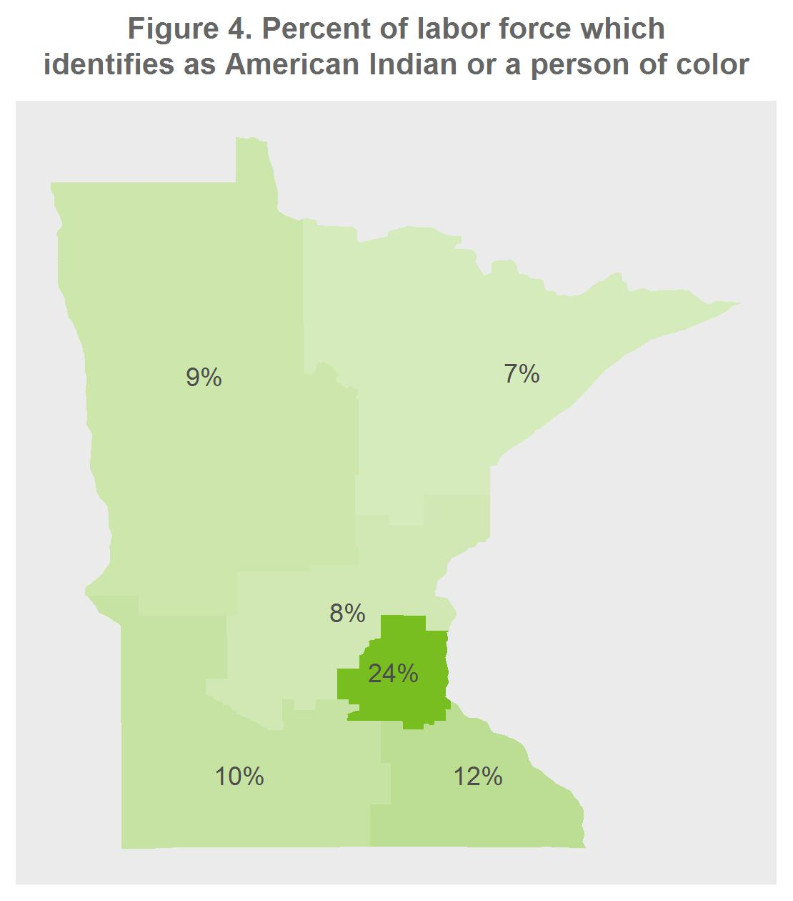
Minnesota’s current labor force (those of working age who are either employed or unemployed) is 17 percent people of color or American Indian, but this figure varies widely by region. Communities of color are most concentrated in the Twin Cities region, at 24 percent, and least concentrated in Northeast Minnesota, at seven percent (Figure 4). Rates across the five Greater Minnesota regions are fairly similar, especially in comparison with the Twin Cities.
Employer perceptions of their own diversity varies greatly by region, both with and without an external benchmark like the diversity of their community. Almost four in five Twin Cities employers rate themselves as diverse, according to their own definition of diversity (which may include race, age, gender, and other factors). This is the highest of any region (Figure 5, next page). In contrast, just three in five employers in Central Minnesota rate themselves as diverse.
Source: U.S. Census Bureau, American Community Survey
However, this pattern flips when employers report whether the racial diversity of their workforce matches or exceeds the diversity of their city or town: Twin Cities employers are the least likely to report being as diverse as their city or town (Figure 6, next page). These results point to the importance of considering diversity, and especially racial diversity, in a local context.
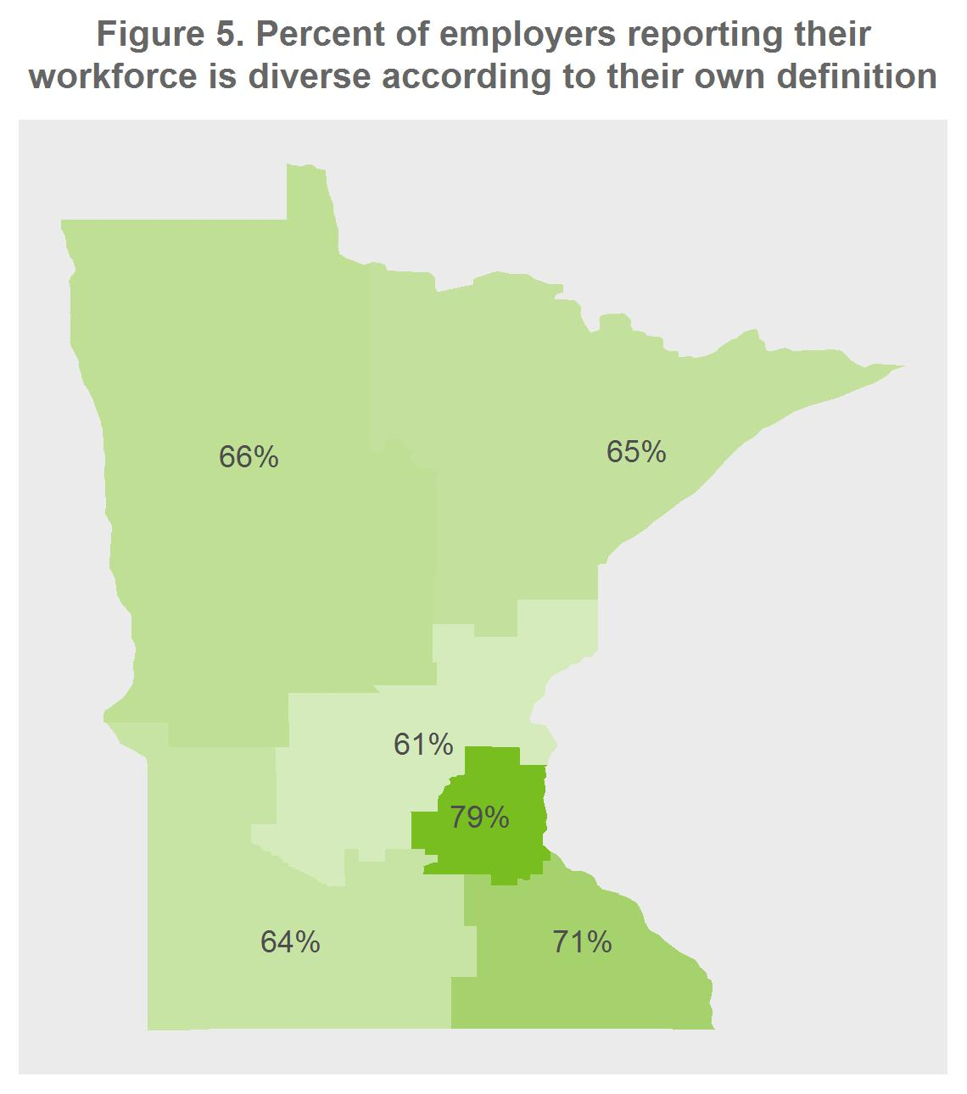
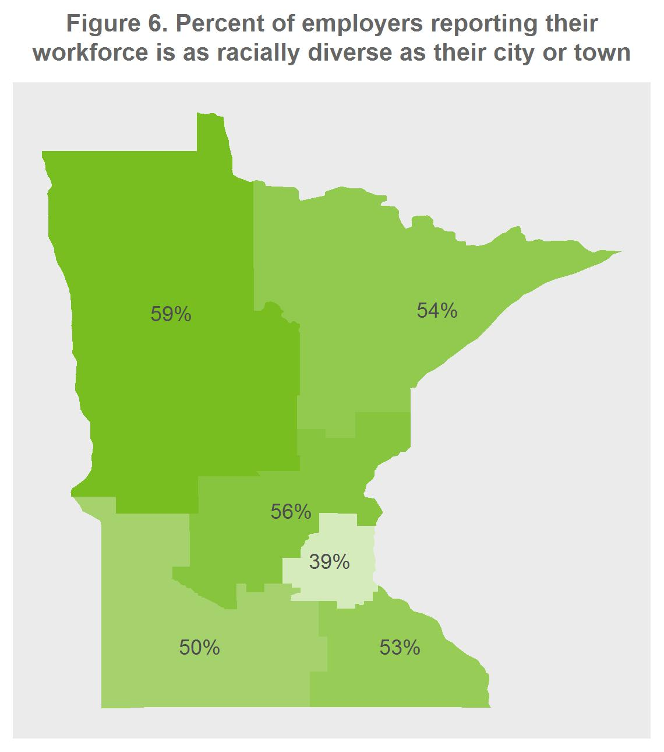
Workers of color are slightly more concentrated in large firms, according to Census data (Figure 7, next page). (Note a small difference in definition of “small firms” between Census data and DEED’s survey). Part of this difference could be due to the concentration of large firms in the Twin Cities, Minnesota’s most racially diverse region; the available data are not granular enough to test this.
Small firms are significantly less likely to report that their workforce is diverse. Three out of four large and medium sized firms rate themselves as diverse according to their own definition, but significantly fewer small businesses do: just three out of five (Figure 8, next page).

Source: U.S. Census Bureau, Quarterly Workforce Indicators
When asked to rate their workforce diversity relative to their community, small firms report being equally or more diverse at a higher rate than large firms (Figure 9). This trend holds true even within the diverse Twin Cities region.
Comparing these responses to those on the percent reporting their workforce is diverse according to their own definition (Figure 7) yields some surprising trends. Once given a benchmark (their community) and instructed to limit diversity to racial diversity, much fewer large employers rate themselves as diverse (75 percent falls to 59 percent) while over 60 percent of small employers rate themselves as diverse under both criteria.
This could be due in part to large employers’ broader definitions of diversity, which include more factors other than race.
Leisure and Hospitality employers in Minnesota have the highest concentration of workers of color, at 22 percent, and Construction has the lowest, at eight percent (Figure 10).
Source: U.S. Census Bureau, Quarterly Workforce Indicators
The relative racial diversity among industries largely aligns with employers’ self-assessment of their own diversity using their broader definition of diversity (Figure 11).
One exception is of note: although Construction is the least racially diverse industry in Minnesota, three out of four construction firms report that their workforce is diverse according to a broad definition, among the highest rate of any industry. One explanation could be that the emphasis on both gender and racial diversity (through explicit hiring targets in government contracts) means racial diversity alone is not a good proxy for overall perceived diversity.
Government and Education Services have a significantly lower rate of self-assessed workforce diversity than most other industries (with the exception of Natural Resources and Mining): only about half report that their workforce is diverse according to their stated definition.

Industries have different customer bases and likely have varying levels of pressure to match the diversity of their customer base in their workforce. Government and Education Services have significantly higher rates than other industries of reporting their workforce is less diverse than their customer base: they also have the broadest (and, for Education Services, the youngest) customer base (Figure 12).
The goods-producing industries (Manufacturing, Natural Resources and Mining, and Construction) and Professional and Business Services had the most difficulty answering this question (up to two in five report being unsure), presumably because their customer base tends to be other business entities rather than individual consumers.

Employers in the Natural Resources and Mining industry are most likely to rate themselves as more diverse than their city or town (Figure 13), a result driven by employers in agriculture, half of whom report being more diverse than their city or town (not shown). According to Census data, 12 percent of agricultural employees in Minnesota are Hispanic or Latino, the highest rate of any industry. Moreover, this employment is concentrated in rural areas which tend to be less racially diverse.

While government employers rate themselves the least diverse compared to their direct competitors, employers in Education Services are among the top (Figure 14)—what could account for this divergence between the two industries which consistently rank themselves among the least diverse? One possibility is that the competition for Education Services workers is more limited: workers tend to be highly credentialed in teaching (which translates into higher costs of changing occupations) with fewer private sector opportunities in their profession than Government workers, who may be able to continue in their communications, research, administrative, or other profession in the private sector.
Finally, employers in Leisure and Hospitality rate themselves as highly diverse relative to all three benchmarks provided. Age of worker may be a factor here, as this industry includes many typical first jobs that a young adult might hold, from fast food worker to movie theatre attendant.

Are employers trying to increase the diversity of their workforce?
Business literature on diversity suggests many efforts to diversify are more successful in entry-level positions than in higher-level positions. At the same time, the successful retention of staff can depend on having a diverse management team, both so staff can see a career progression for themselves and also so they can be mentored by managers of similar backgrounds. Because of this, employers may have different diversity strategies for their entry-level positions than their management-level positions.
57 percent of employers report actively trying to increase racial diversity in entry-level positions; 53 percent in management positions. This difference is within the margin of error, implying that most employers tend to view diversity at all levels as occurring simultaneously.
Academic and business literature suggests a strong business case for employing a diverse workforce, from improving the workplace culture to increasing the productivity and creativity of teams, as well as a social responsibility case for improving employment equity. The literature also suggests that racial diversity may signal to applicants of all races that they will be welcomed, increasing the potential applicant pool.
66 percent of employers indicate that they would seek to increase racial diversity to attract the best applicants (Figure 15). Additional reasons that resonate with respondents are to improve their work environment or culture (44 percent) and to improve racial equity (41 percent).

Twin Cities employers are most likely to report actively promoting diversity (72 percent, Figure 16) and are most likely to report that others in their region are actively promoting diversity (42 percent, Figure 17), while employers in Northwest and Southwest Minnesota are least likely to do either. The similarity in the regional patterns between these two questions implies that employers do have a good idea of how other employers in their region are approaching diversity.

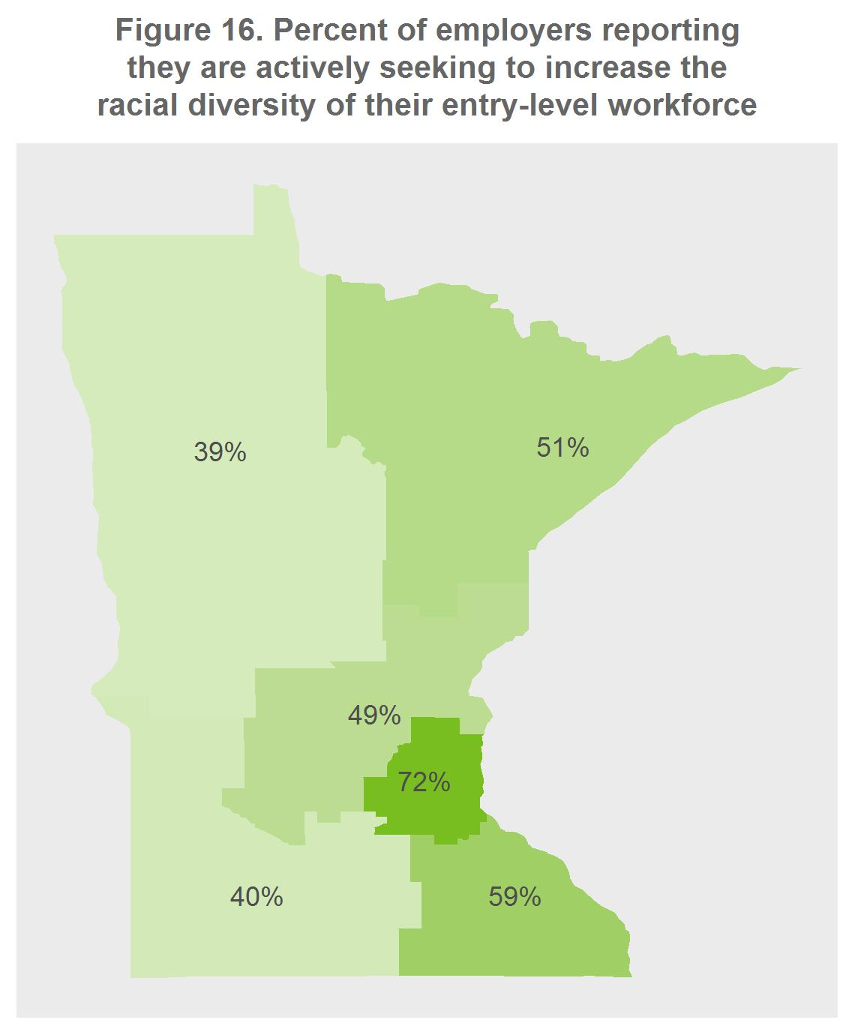
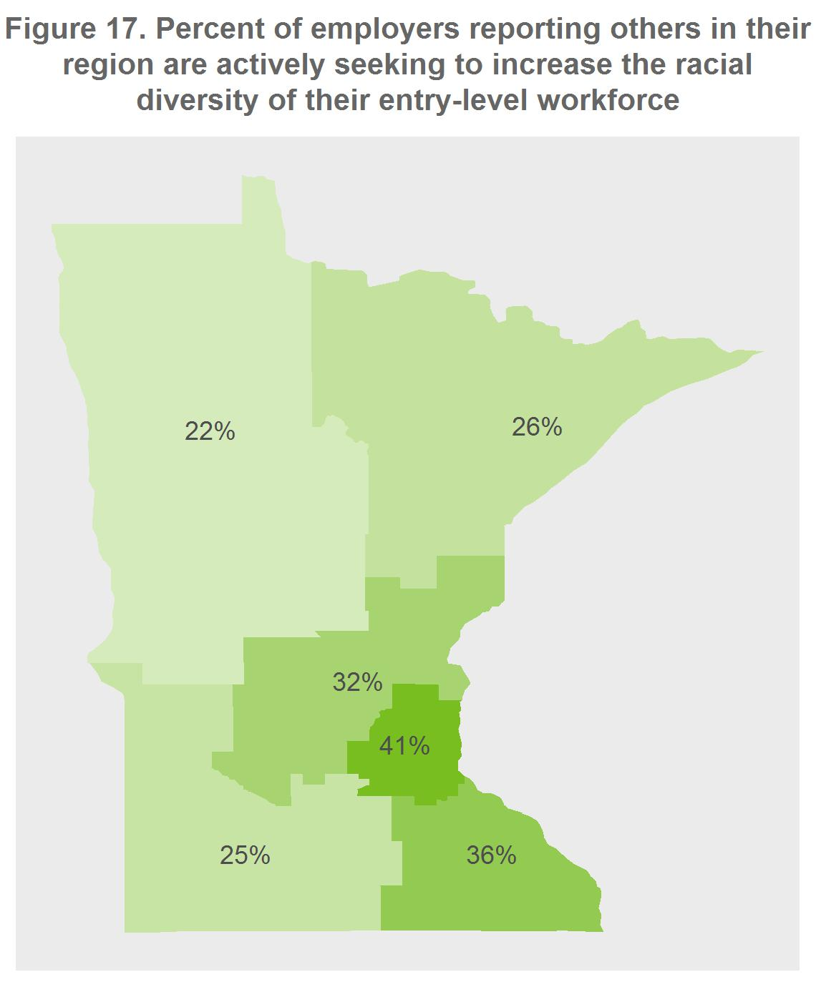

The regional landscape of diversity in Minnesota affects how employers approach diversity. Employers in Northwest and Southwest Minnesota are much less likely to report that they would increase racial diversity to improve racial equity (Figure 18). This suggests that some of the business rationales to increase diversity will be more salient in some regions than in others.
Efforts to diversity vary widely by firm size as well (Figure 19). Nearly four in five large employers in Minnesota are seeking to increase their workforce diversity, but fewer than two in five small employers are: a striking 50 percentage point divide.
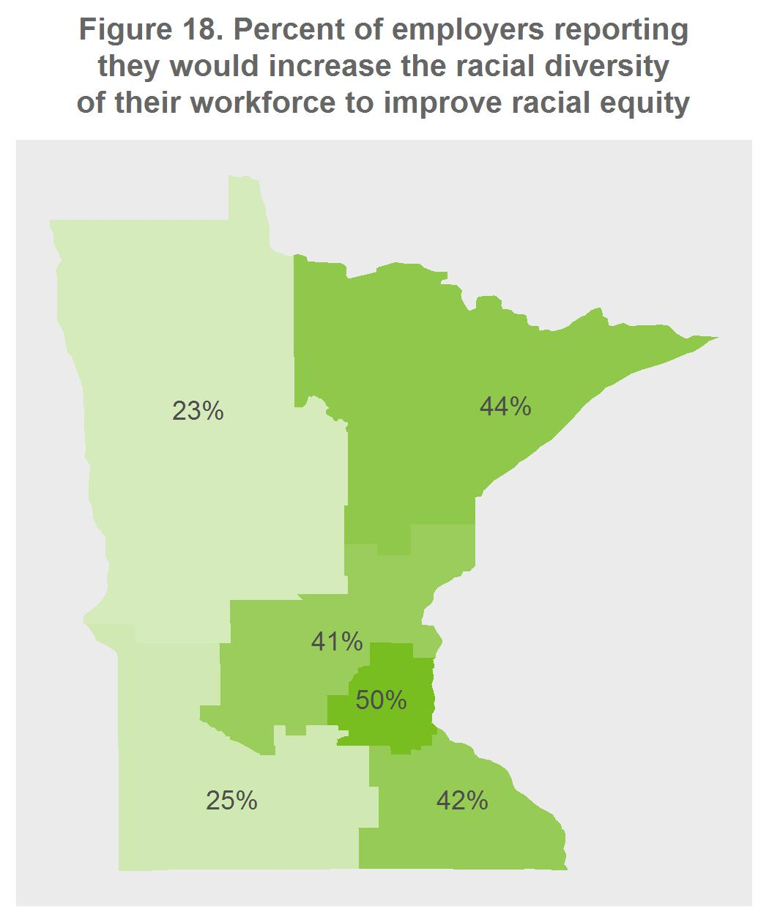
Consistent with the finding that only about one in four small firms report that they are actively seeking to increase the racial diversity of their workforce, small firms are significantly less likely than large firms to agree with any of the provided reasons for increasing the racial diversity of their workforce (Figure 20). Even among small businesses, though, over half agree that they would increase the racial diversity of their workforce to attract the best applicants.

Education Services, Construction, and Government employers are significantly more likely than those in other industries to report that their industry is trying to diversify their entry-level workforce (Figure 21). Each of these three industries has seen public pressure to increase diversity where public funds are involved.
In each industry, employers report that they are trying to increase racial diversity at a higher rate than other employers in their industry (Figure 22). The two questions have two different sources of potential bias in opposite directions: a potential lack of knowledge about other employers’ efforts gives us a likely lower bound, while the tendency to over-report their own efforts gives us a likely upper bound, on a true rate.
Once again, Education Services and Government employers stand out: they have the closest rate between the two questions, with a two and five percentage point differential in entry-level diversity efforts (respectively) compared to 17 to 26 percentage point differential among all other industries. Government and Education Services employers may have stronger networks and therefore better information sharing around diversity efforts.

How are employers managing the diversity of their current workforce?
The academic and business literature on best practices in managing workforce diversity identifies multiple strategies; this survey included ten that cover a range of strategy areas, from hiring to retention to staffing organization. 80 percent of employers are engaging in at least one best practice in recruitment and retention, most commonly by ensuring that the stated minimum qualifications are truly required and by paying for the professional development of employees (Figure 23).
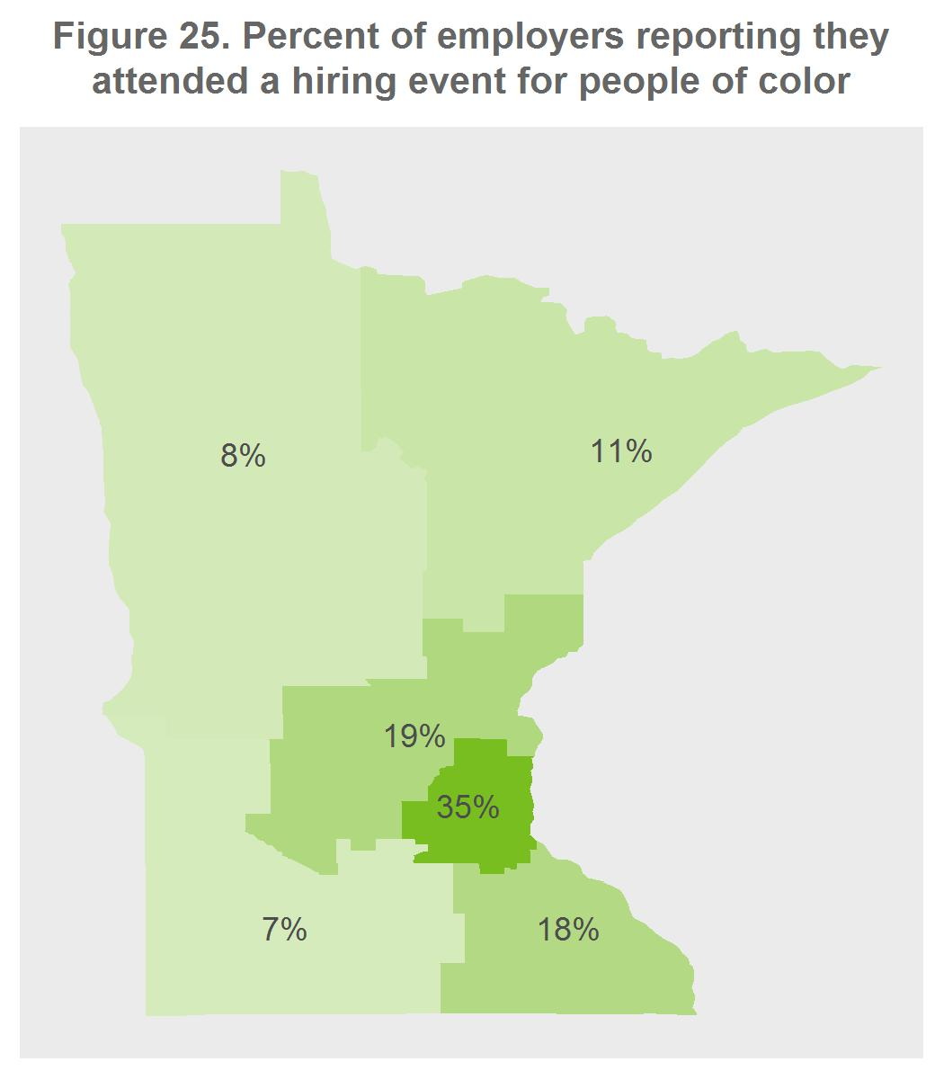
Nearly half of employers are engaging in higher-level leadership best practices which ensure that a commitment to diversity has been included in the employer’s strategic direction (Figure 24, previous page). The most common best practice in this group is senior leadership communicating a commitment to diversity which, although it is “only talk”, sets the tone for the organization and effectively acts as a prerequisite for other management activities.
Additionally, some recruitment best practices to increase workforce diversity depend on a minimum threshold of diversity in the available labor pool, including attending hiring events focused on people of color. Indeed, this strategy is most common among Twin Cities employers (Figure 25). This highlights the need to view workforce diversity relative to the employer’s location within Minnesota and adjust strategies accordingly.
Small firms are significantly less likely to engage in the best practices in managing diversity suggested by business and academic literature (Figures 26 and 27, next page). It is important to note that these best practices tend to be discussed and recommended in the context of large corporations; very little of the literature addresses smaller businesses. It may be that small firms are effectively managing their workforce diversity using other practices not included in the survey. Small businesses are relatively more likely to support a formal mentoring program among employees than participate in hiring events focused on people of color or make diversity training available to all employees, distinct from large employers. Mentoring is not explicitly about diversity, which may account for this trend.

Table 2. Percent agreeing with the following reasons to increase the racial diversity of their workforce, by industry
 | To attract the best applicants | To improve work environment or culture | To improve racial equity | To increase customer appeal | To increase employee productivity | Other - Write In | Not applicable | Unsure/ don't know
Other Services | 72% | 55% | 51% | 30% | 13% | 4% | 9% | 9%
Government | 70% | 49% | 51% | 35% | 27% | 7% | 11% | 10%
Professional and Business Services | 70% | 56% | 47% | 19% | 16% | 8% | 10% | 9%
Health Services | 66% | 44% | 42% | 30% | 21% | 11% | 11% | 6%
Financial Activities | 65% | 35% | 27% | 23% | 13% | 10% | 10% | 13%
Trade, Transportation, and Utilities | 65% | 39% | 35% | 38% | 20% | 5% | 12% | 11%
Education Services | 65% | 53% | 60% | 40% | 20% | 17% | 5% | 10%
Leisure and Hospitality | 64% | 41% | 38% | 24% | 26% | 6% | 13% | 14%
Natural Resources and Mining | 63% | 23% | 6% | 11% | 29% | 6% | 14% | 20%
Manufacturing | 60% | 29% | 30% | 6% | 12% | 14% | 13% | 11%
Construction | 55% | 36% | 36% | 19% | 29% | 24% | 10% | 14%

Industries vary widely in their selection of reasons to increase the racial diversity of their workforce; this variance is most pronounced for the reason “To improve racial equity”, which speaks to a less profit-driven motivation (Table 2). Just six percent of employers in Natural Resources and Mining reported that racial equity would be a reason for them to increase racial diversity, while over half of Education Services, Government, and Other Services employers agreed with that reason.
Employers in Education Services, Trade, Transportation, and Utilities, and Government agree with “To increase customer appeal” at relatively high rates; this is consistent with the general public focus of government and education, and employers in retail, who compete with each other for younger (and more diverse) customers, may be driving this result in the Trade, Transportation, and Utilities sector.
Construction employers are most likely to write in a reason why they would increase the racial diversity of their workforce; nearly half of these responses cite the requirements for diversity laid out in government contracts.
One trend unites all industries: employers are significantly more likely to agree with “To attract the best applicants” than any other reason.

Table 3. Percent reporting they have engaged in the following recruitment and retention best practices within the past three years, by industry
 | Ensure that stated minimum qualifications are truly required | Pay for professional development of employees | Make diversity training available to all employees | Participate in hiring events focused on people of color | Support a formal mentoring program among employees | Other | None of the above
Government | 75% | 58% | 43% | 23% | 17% | 5% | 11%
Health Services | 67% | 58% | 40% | 25% | 28% | 4% | 7%
Professional and Business Services | 59% | 52% | 28% | 24% | 39% | 9% | 15%
Education Services | 58% | 82% | 48% | 27% | 49% | 2% | 5%
Financial Activities | 54% | 50% | 29% | 13% | 17% | 2% | 21%
Other Services | 53% | 51% | 30% | 23% | 23% | 4% | 19%
Trade, Transportation, and Utilities | 51% | 37% | 31% | 20% | 23% | 6% | 23%
Manufacturing | 48% | 46% | 25% | 22% | 22% | 8% | 27%
Construction | 46% | 41% | 22% | 34% | 15% | 12% | 22%
Leisure and Hospitality | 38% | 21% | 15% | 13% | 16% | 5% | 47%
Natural Resources and Mining | 29% | 23% | 16% | 10% | 10% | 10% | 48%

Employers in the Education Services industry are the most likely to report paying for employee professional development, making diversity training available to all employees, and supporting a formal mentoring program among employees (Table 3).
Employers in the Construction industry are the most likely to report they participate in hiring events for people of color—relatively fewer report doing any of the other best practices around retention rather than recruitment.
Government and Health Services employers are the most likely to report that they have ensured that the stated minimum qualifications on job postings are actually necessary. Both of these industries tend to have large employers with centralized human resource functions and policies—whose very efficiency can maintain a status quo, for instance in minimum qualifications, past its usefulness.
Employers in Leisure and Hospitality and Natural Resources and Mining are most likely to report doing none of the above.

Table 4. Percent reporting they have engaged in the following leadership best practices within the past three years, by industry
 | Senior leadership communicate commitment to diversity | Develop a clear business rationale for increased diversity | Devote an office, department, or task force to increasing diversity | Include progress on diversity goals in at least one manager's job review | Establish explicit goals for the use of women- or minority-owned suppliers | Other | None of the above
Education Services | 53% | 31% | 33% | 31% | 9% | 2% | 38%
Health Services | 48% | 21% | 18% | 15% | 6% | 2% | 42%
Other Services | 46% | 20% | 13% | 13% | 11% | 9% | 48%
Construction | 39% | 27% | 17% | 15% | 24% | 7% | 39%
Professional and Business Services | 37% | 22% | 16% | 14% | 11% | 6% | 50%
Government | 34% | 23% | 15% | 9% | 9% | 6% | 48%
Trade, Transportation, and Utilities | 29% | 18% | 12% | 11% | 9% | 6% | 60%
Manufacturing | 27% | 16% | 10% | 11% | 5% | 6% | 56%
Leisure and Hospitality | 22% | 16% | 7% | 2% | 3% | 4% | 72%
Financial Activities | 20% | 20% | 12% | 10% | 8% | 6% | 58%
Natural Resources and Mining | 10% | 16% | 3% | 3% | 3% | 10% | 74%

About half of employers in Education, Health, and Other Services say their senior leadership communicate a commitment to diversity (Table 4). Remember, Other Services includes advocacy and civic organizations. Education and Construction employers are most likely to have a clear business rationale for increased diversity, presumably from research finding students with at least one teacher of a similar background have better educational outcomes to government contracts requiring a certain percentage of women and people of color working on (and supplying) a construction project.
Once again, employers in Leisure and Hospitality and Natural Resources and Mining are most likely to report doing none of these.

Conclusion
While this report illuminates the current state of workforce diversity in Minnesota, it also raises important questions that remain unanswered:
- Is there a business case for diversity that can appeal specifically to small employers? Are there best practices in managing diversity that are unique to small employers? What’s already working for small businesses in Minnesota?

- What best practices can Minnesota’s already-diverse sectors, like Manufacturing, Leisure and Hospitality, and Natural Resources and Mining, implement around retaining diverse talent and implementing career pathways into higher wage occupations? What’s already working in these sectors?
Further research and outreach to employers will help to address these questions and aid Minnesota’s employers in welcoming tomorrow’s more diverse workforce.

Minnesota Population Projections by Race and Hispanic Origin, 2005 to 2035, Minnesota State Demographic Center, January 2009
The Economic Status of Minnesotans: A Chartbook With Data For 17 Cultural Groups, Minnesota State Demographic Center, January 2016.
Note that the Other Services industry is a catchall category that includes “equipment and machinery repairing, promoting or administering religious activities, grantmaking, advocacy, and providing drycleaning and laundry services”. The full definition is available on the Bureau of Labor Statistics website.

